May 10, 2024

Charles E. Patterson, President
Shippensburg University

Dear President Patterson:

The Accrediting Council on Education in Journalism and Mass Communications met May 3, 2024, in Washington, D.C. , and voted 14-0, with three recusals, that the undergraduate program in the Department of Communication, Journalism and Media at Shippensburg University receive reaccreditation. Chair Carrie Sipes attended the meeting.

The Council concurred with the site team and Committee recommendations for reaccreditation.

We will be in touch with Dr. Sipes about the next visit for the school, scheduled for the 2029-2030 academic year.

Thank you for the opportunity to participate with your faculty and administrators in the assessment of your program. The goal of the Accrediting Council is to improve the quality of education offered to students served by a program through that assessment. Please accept my congratulations and best wishes for success for the Department of Communication, Journalism and Media; its students; faculty and the professional media constituencies it serves.

Sincerely,
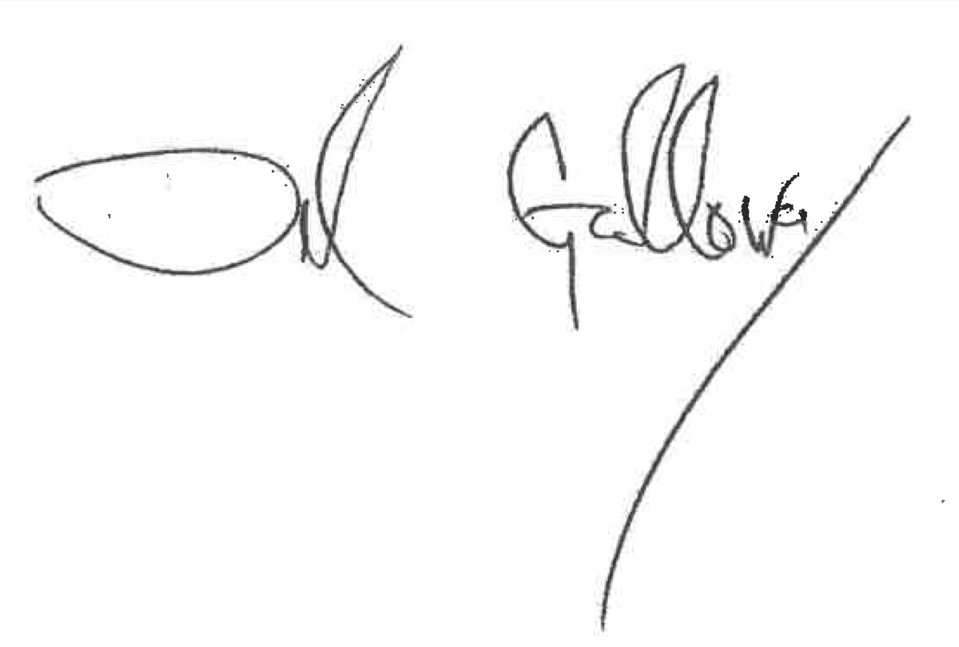
Del Galloway, ACEJMC President

cc: Carrie Sipes, Chair
Brad Rawlins, site team chair
Marie Hardin, chair, Accrediting Committee chair
Patricia Thompson, executive director, ACEJMC

